Phase 2 – Performance Testing
Automation Logic

Description
Automation logic is implemented using ServiceNow Flow Designer to automate the complete employee onboarding and offboarding lifecycle. The flow is triggered on catalog submission and performs actions such as data capture, record creation, approvals, notifications, and status updates with minimal manual effort.

Activity 1: Creation of Flow
Description
- Navigate to Flow Designer from the Application Navigator.
- Click New to create a new flow.
- Provide the Flow Name as Onboarding and Offboarding flow.
- Enter an appropriate description for the flow.
- Click Build Flow to proceed with configuration.
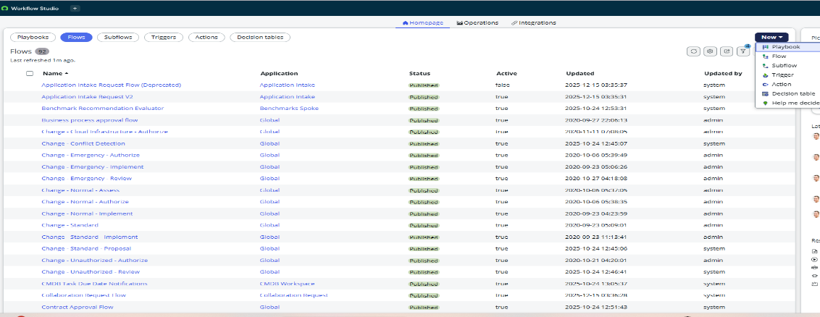

Activity 2: Configuring Trigger
Description
- Click on the ( + ) icon to configure the trigger.
- Select Application → Service Catalog as the trigger type.
- Choose the appropriate catalog item.
- Click Done to save the trigger configuration.
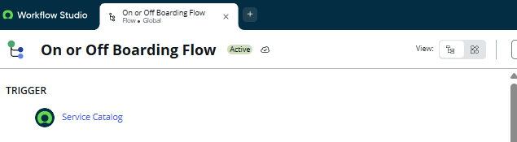
Flow Trigger
The flow is triggered when the Onboard New Employee Service Catalog item is submitted.
Automation Flow Steps
Step 1: Get Catalog Variables
The flow begins by retrieving all catalog variables submitted as part of the onboarding request. These variables are used throughout the flow for record creation, approvals, and task processing.
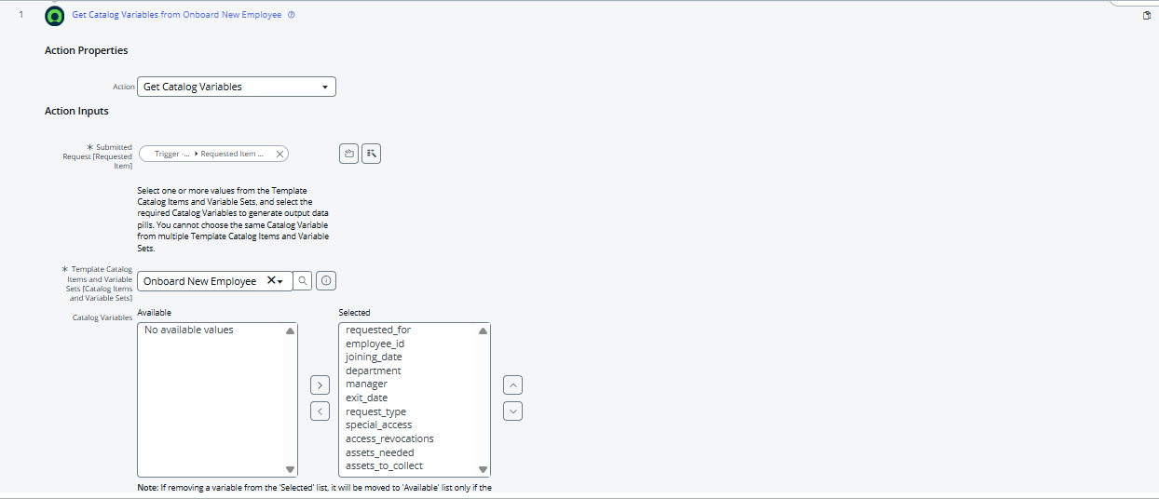

Step 2: Request Type Validation
A condition check is performed to verify whether the Request Type is Onboarding.
If the condition is met, the flow proceeds with onboarding automation.
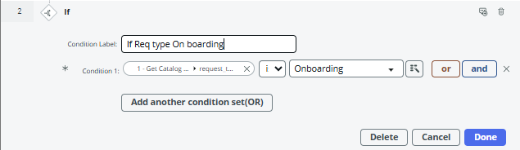
Step 3: Create Employee Lifecycle Record
A new record is created in the Employee Lifecycle table to store onboarding-related information captured from the request.
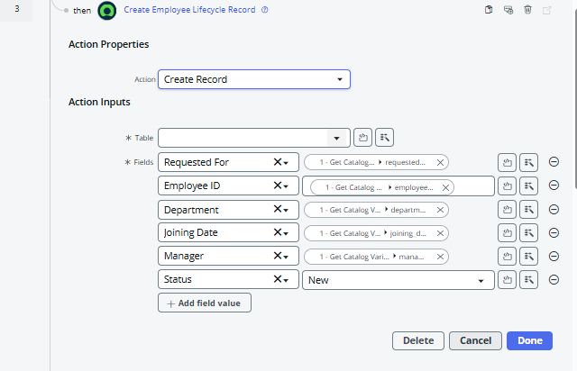
Step 4: Approval Process
An approval is requested on the Requested Item to ensure managerial or policy-level authorization before proceeding.
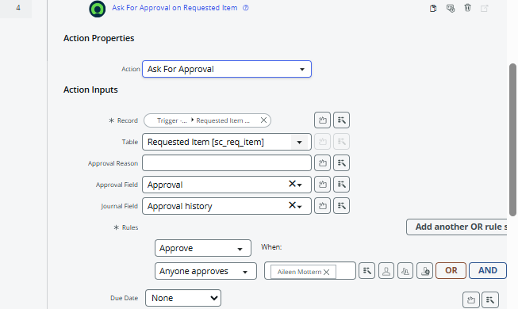

Approval Outcome Handling
If Approved
When the request is approved, the following actions are executed:
- Create multiple Catalog Task records to handle onboarding activities such as access provisioning, asset allocation, and system setup
- Wait for the Requested Item to reach the Closed Complete state
- Update the Requested Item record with the final status
- Send an automated email notification confirming successful onboarding
- End the flow
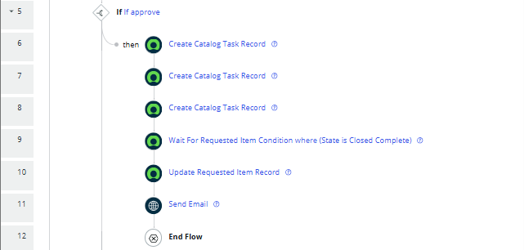
If Rejected
If the request is rejected, the flow performs the following actions:
- Update the Employee Lifecycle record with rejection details
- Update the Requested Item record to reflect the rejection status
- End the flow
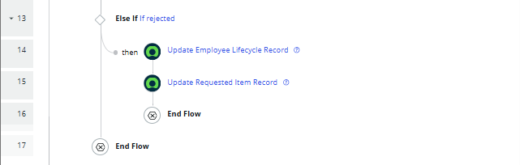
Outcome
This automation flow ensures a structured and auditable onboarding process by automating approvals, task execution, record updates, and notifications. It improves process efficiency, reduces manual coordination, and provides clear visibility into the onboarding lifecycle.

